Practical activity: Whoosh Bottle Demonstration
Demonstration Guide – Whoosh Bottle

Aim: To demonstrate the violent flammability of hydrocarbon vapours
Notes and guidance
This practical can be very dangerous if carried out unsafely. Please see the risk assessment notes below, consult CLEAPSS if you have any questions about carrying out this practical safely.

This demonstration may not have as much obvious educational value as other practicals in the Science Mastery curriculum, but it is always incredibly engaging for students. You may wish to carry this out towards the start of the year or whenever students need to be reminded how exciting practical science can be.

If you only have time/equipment to carry out this demonstration with one chemical, propan-2-ol gives the best balance between an impressive ‘whoosh’ and an easily visible yellow flame.

You may wish to tie this demonstration in with a lesson about energy (huge amount of energy released from a small amount of fuel) or chemistry (flame colours varies depending on the proportion of carbon inside the molecule).
Risk Assessment Notes
A risk assessment must be completed for this practical. The risk assessment should be specific to the class involved and written only by the teaching member of staff. For more guidance refer to CLEAPSS. It is good practice for students to wear safety spectacles during all class practicals and demos.

CLEAPSS Hazcards:
- Propan-1-ol – 84A – Highly flammable, may cause drowsiness/dizziness, causes serious eye damage
- Propan-2-ol – 84A – Highly flammable, may cause drowsiness/dizziness, causes serious eye damage
- Industrial Denatured Alcohol (IDA, or ethanol) – 40A – Highly flammable, harmful if swallowed, may cause organ damage
- Methanol – 40B – Highly flammable, toxic, and can cause organ damage if swallowed, inhaled, or in contact with skin
Do not use any flammable chemicals other than the ones listed above for this demonstration. Do not use methanol if the room temperature is > 22 °C. Never add additional gases such as pure oxygen to the bottle.

Do not use any other bottle than a 16-20 litre polycarbonate (identifiable by a ‘PC’ mark on the base) water cooler bottle. Under no circumstances should you use a glass bottle. Check the bottle for signs of damage, frosting, or cracking and do not use if there is any signs it is damaged.

Place the bottle on a stable base at least 2.5 m from the ceiling of the lab. Remove any paper mobiles or displays from the demonstration area.

Everyone in the room should be wearing eye protection. Students should be stood at least 4 m away from the bottle with a safety screen separating them from the bottle.

A build-up of vapour pressure inside the bottle may cause some excess alcohol to spray out when the stopper is removed. Take care when un-stoppering the bottle, protect yourself and your audience, and wipe up any spillage before ignition.

Remove all excess alcohol from the bottle before ignition to avoid melting the plastic. If a liquid fire starts, re-stopper the bottle. If the demonstration fails, do not attempt to repeat it. The bottle must be washed and thoroughly dried before further use.

Before carrying out this demonstration, ensure a fire blanket and fire extinguisher are available. Discuss the dangers of this practical with your class and ensure they know what to do in case of an emergency.

If transporting a filled water cooler bottle, ensure this is risk assessed. CLEAPSS Laboratory Handbook section 3.7 provides guidance for risk assessing under the Manual Handling Operations Regulations. It is likely that two people will be required to lift and carry a full water cooler bottle of 16-20 kg.

Any deviation from the CLEAPSS risk assessment must be cleared with CLEAPSS, your Head of Department, and your technician colleagues.
Equipment | Equipment Setup  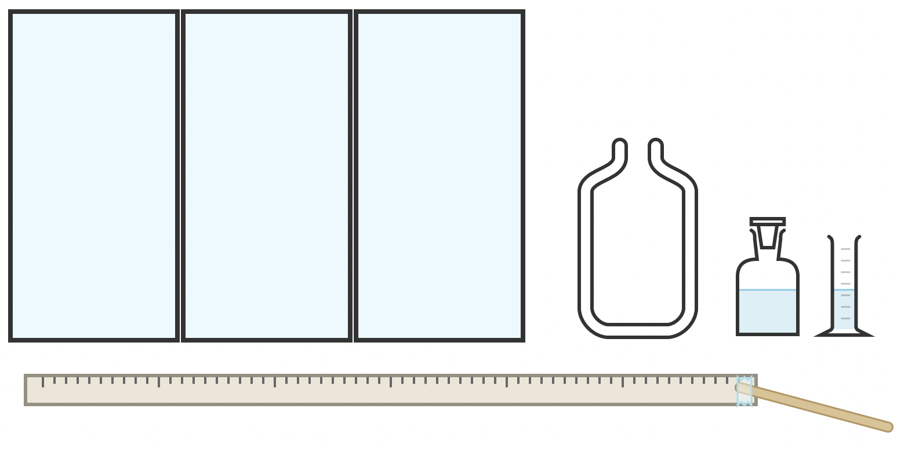
Apparatus:
- Stable surface 2.5 m from lab ceiling
- Polycarbonate water cooler bottle approx.. 18 litres – completely dry
- Stopper that fits the water cooler bottle
- Metre ruler
- Tape
- Wooden Spints
- Lighter
- 50 ml measuring cylinder
- Beaker

Chemicals:
- Propan-2-ol
- Propan -1-ol (optional)
- IDS Ethanol (optional)
- Methanol (optional – do not use if lab temperature is greater than 22 °C)

Method |  | Questions To Ask Students During The Practical
- Set up the demonstration area with the polycarbonate bottle 2.5 m from the ceiling, on a stable surface, and behind a protective screen.  - Ensure everyone in the room is wearing eye protection. The audience should be stood at least 4 m from the bottle.  - Measure out 40 ml of your chosen alcohol (propon-2-ol recommended, do not use methanol if the room temperature is > 22 °C).  - Pour the alcohol into the water bottle and insert the stopper.  - Gently roll the bottle on its side for ten seconds so it fills with alcohol vapour.  - Remove the stopper and pour any excess liquid into the beaker. Move this waste alcohol beaker a safe distance (> 1m) from the demonstration.  - Immediately light the wooden splint attached to a metre ruler, stand as far back as possible, and ignite the fumes at the opening of the bottle.  - After the alcohol has burned, pour out any water formed during the combustion reaction, refill completely with water, empty it again, and allow the bottle to completely dry naturally before reuse.  - If the demonstration fails, do not attempt to repeat it. The bottle must be washed and thoroughly dried before further use. |  | - Why must we take so many safety precautions with this demonstration? (A violent combustion can be incredibly dangerous.)  - Why must we thorouhgly check the polycarbonate bottle for any signs of frosting, cracking, or damage before carrying out this demonstration? (If the bottle is weakened, it may explode.)  - Why must we use the safety screen and wear eye protection. (To protect the audience in case of an explosion.)  - Why do we remove the excess liquid before igniting? (To avoid the liquid burning which can be hotter and longer-lasting than the vapour burning, which risks damaging the bottle.)  - Describe the energy transfers occuring in the bottle. (The fuel’s biochemical energy is rapidly transferred to kinetic, sound, and light energy.)  - Why do dfiferent hydrocarbons combust with different flames? (Due to the proportion of carbon in the hydrocarbon molecule.)
Alternative Methods/Computer Simulations |  | Clearing up
Plenty of videos of this phenomenon are available online. You may wish to film a demonstration in your school to replay whenever the topic comes up. |  | It is important that equipment is returned to the prep room in good order. If safe to do so, rinse used equipment and put it in the used equipment tray. If the trays arrived on a trolley, students must return all trays and equipment to that trolley. Anything dirty needs to be placed into a separate container for washing up. Never put dirty equipment back into a tray with clean equipment.  See Hazcards for chemical disposal information. Discuss waste chemicals with your technician colleagues.
Technician Notes
Discuss this practical with the class teacher ahead of time. Ensure they have considered the risks of this practical and are confident with the techniques used. If necessary, provide them with the CLEAPSS risk assessment (identified in the risk section section above).

Check the polycarbonate bottle thoroughly for any signs of frosting, cracking, or damage before putting it out. It must have been washed with water and thoroughly dried before this demonstration.

Teachers must have rehearsed this demonstration before carrying it out.

If you have any H&S concerns about the way this demonstration is being carried out, discuss these with your HoD, your principal, and/or CLEAPSS.

